Guide to application for Veterinary Certificate
SN | Step | Screenshot
1 | Go to AVA e-licensing website  https://licence1.business.gov.sg/AVA/authentication/showLogin.action | 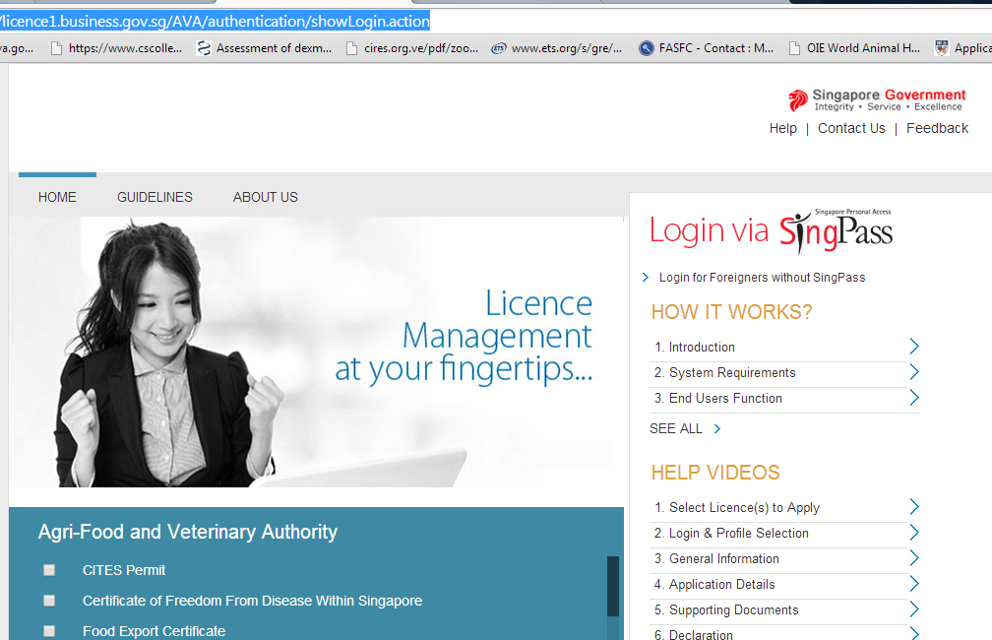
2 | Log in into the system.  For Singaporeans: Login via SingPass  For non-Singaporeans: Login via “Login for foreigners without SingPass”
3 | Select if you are using a personal/individual account or a company’s account.  If applying with a company’s account, provide the UEN number of the company. | 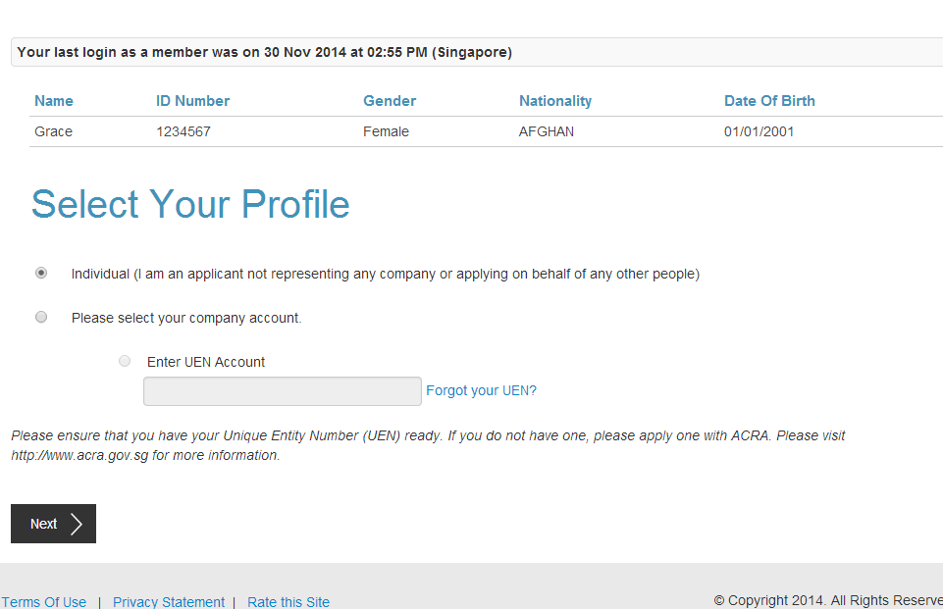
4 | Select “Licence Application” | 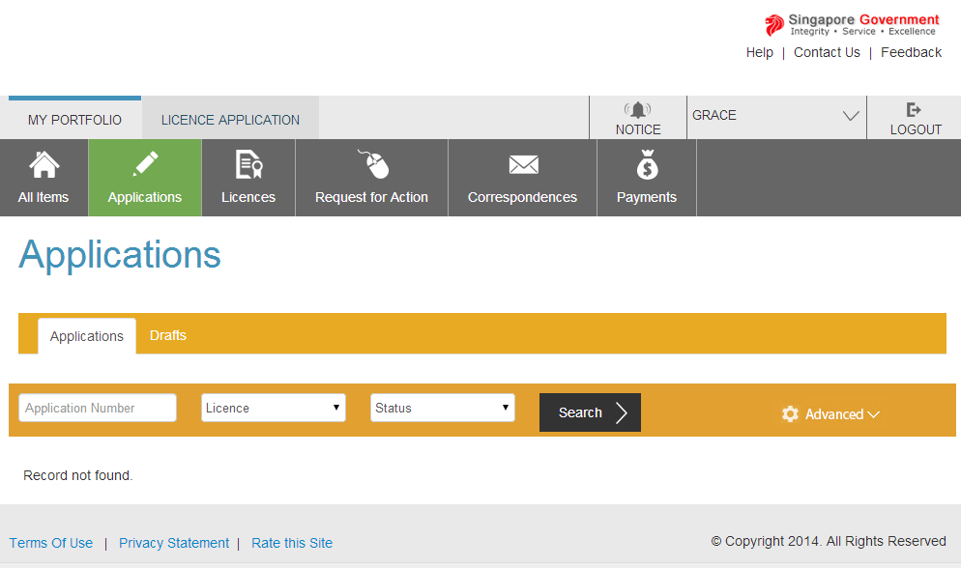
5 | Select “Veterinary Certificate” and click “next”. | 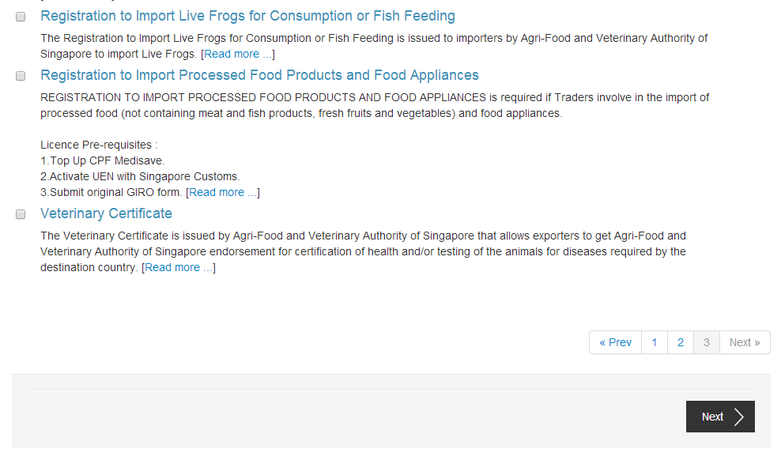
6 | Select “Veterinary Certificate” and click “next”. | 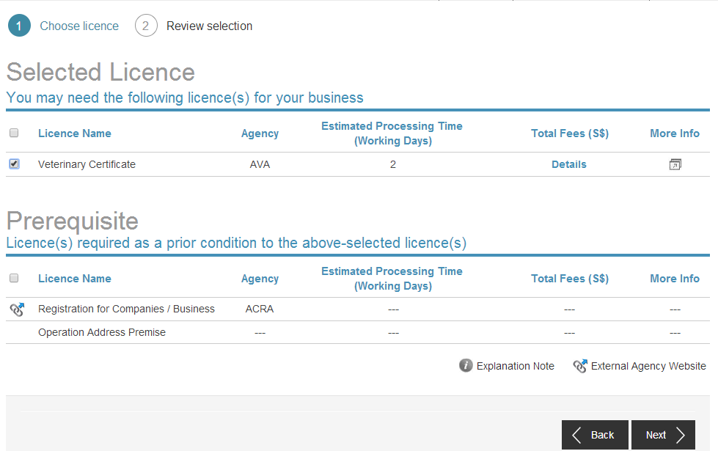
7 | Click “apply” | 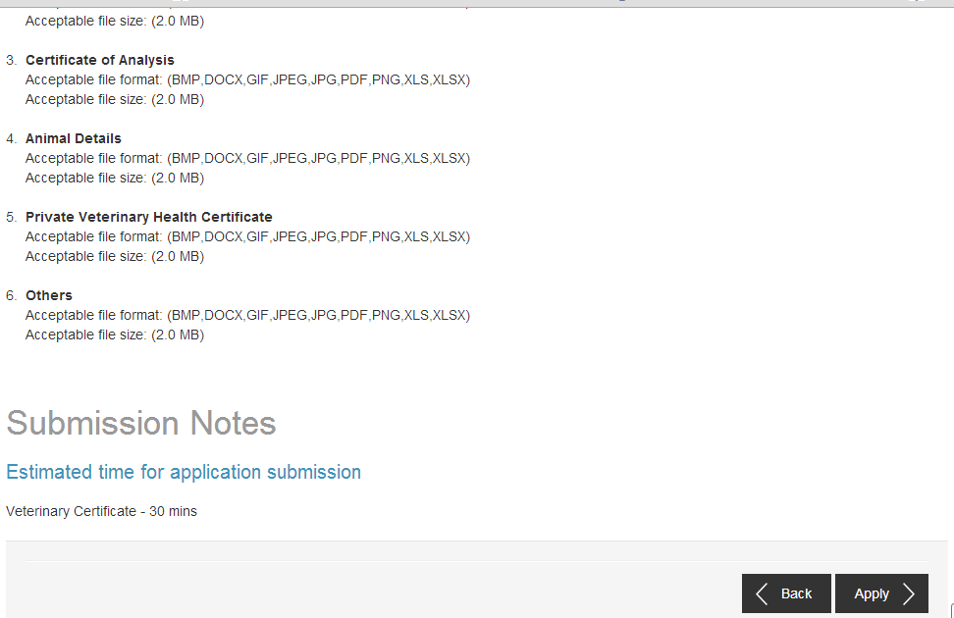
8 | Agree to the terms of use | 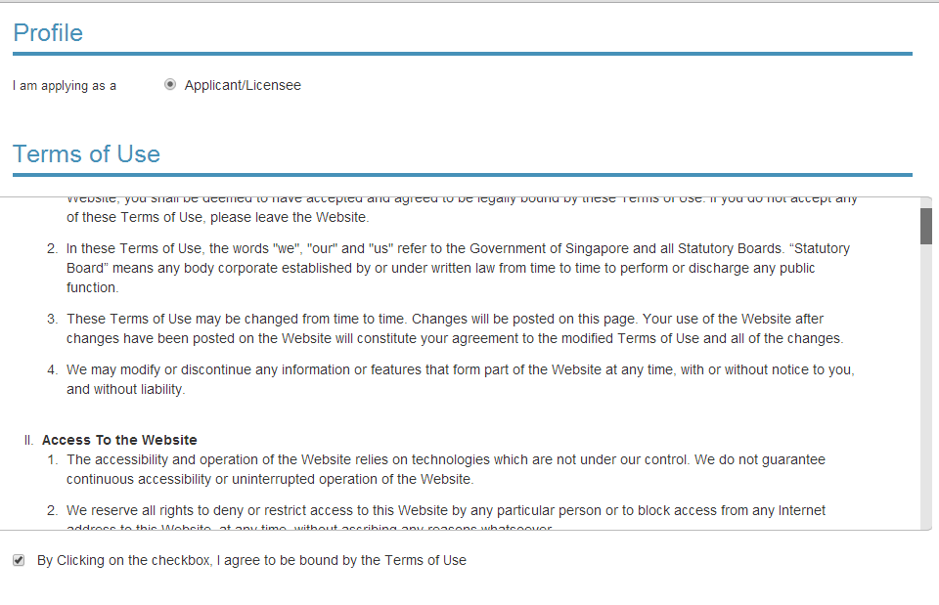
9 | Complete the “Applicant information”, “Applicant address”, and “Mailing address”.  Click “next”. | 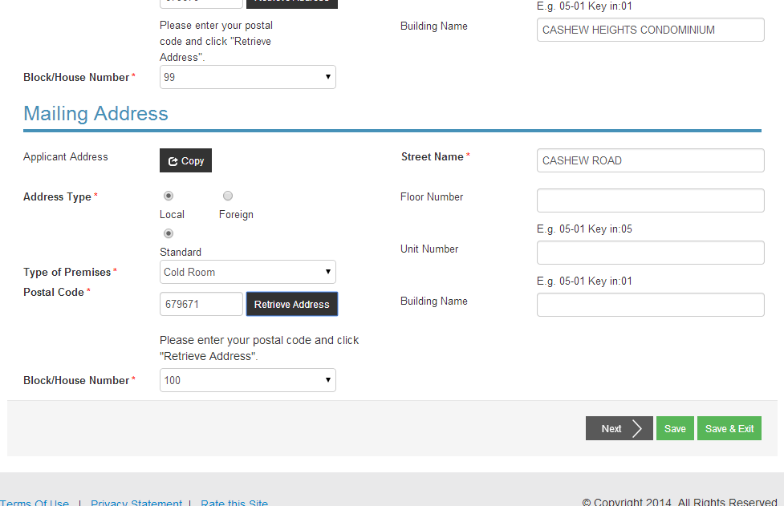
10 | Click “Start” | 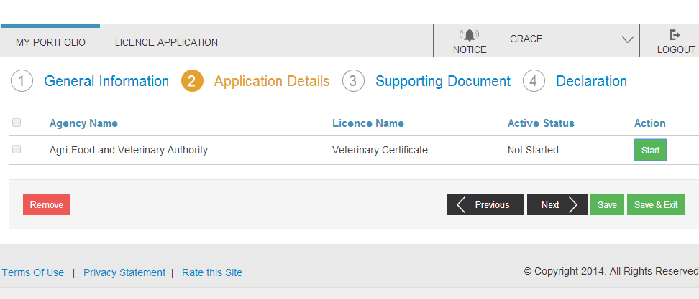
11 | Select the “Certificate Sub-Type” from the dropdown list. | 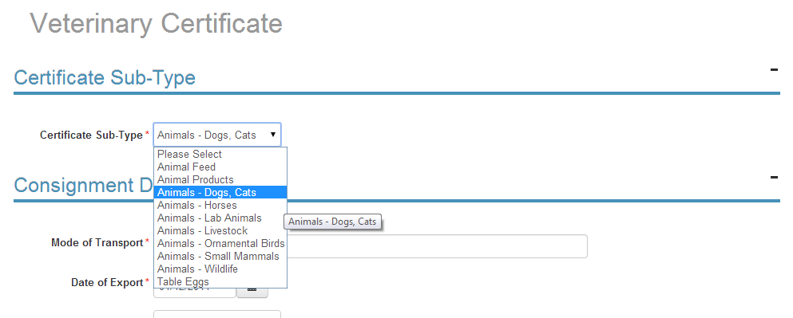
12 | Complete “Consignment Details”, “Consignor Details”, and “Consignee Details”. | 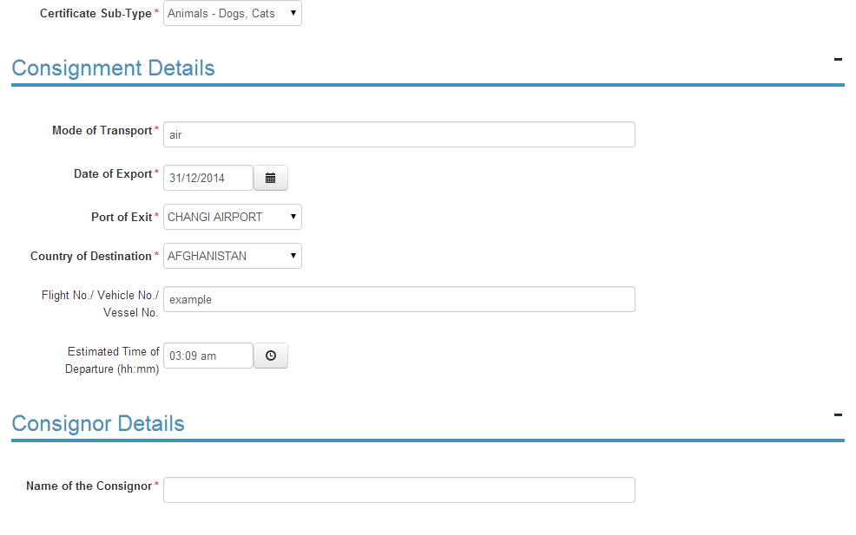
13 | Indicate if you wish to collect the certificate from AVA customer counter.  You can collect the watermarked Health Certificate at AVA Headquarters, or print it with your personal printer which needs to have watermarked functions. | 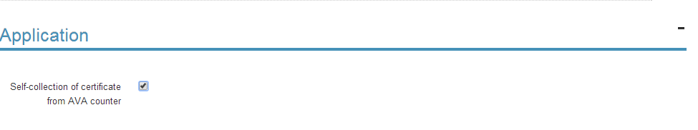
14 | Complete “Emergency Contact”.  Click “Save”. | 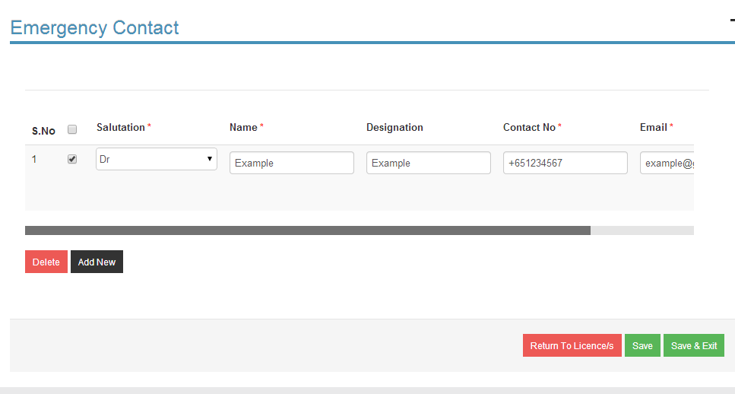
15 | Select “Type of Service”.  Express service (S$46): Issuance within 1 working day from submission of complete supporting documents.  Normal service (S$23): Issuance within 2 working days from submission of complete supporting documents.  For manual endorsement of Health Certificates:  Please select “Normal” as there is no express service. All manual endorsements of certificates are issued within 1 working day from submission of complete documents. | 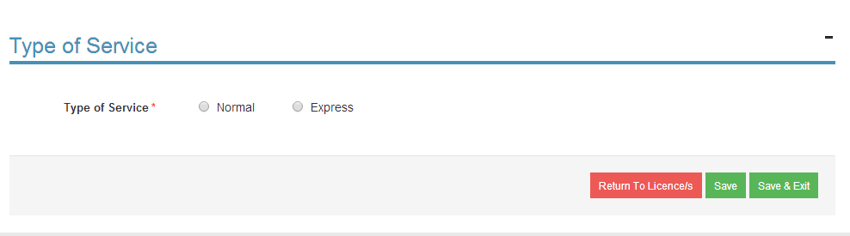
16 | Attach the relevant supporting documents.  Click “Next”. | 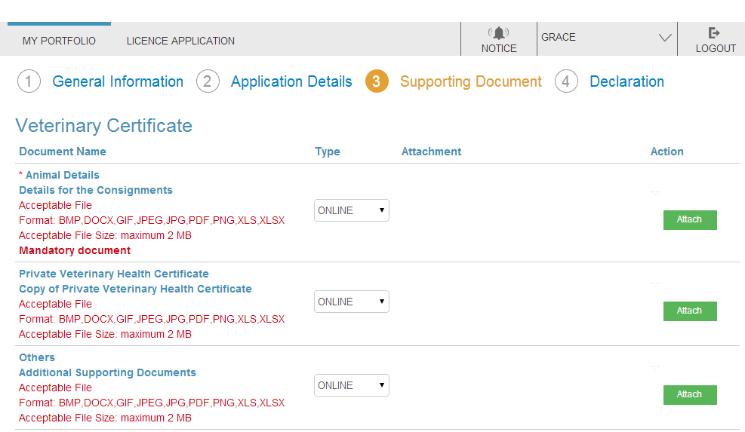  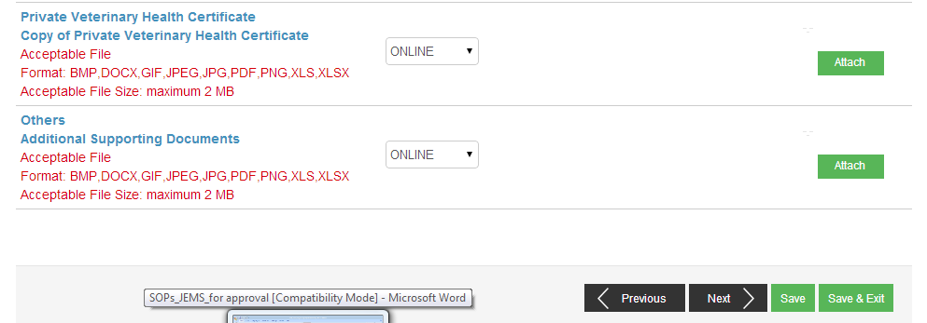
16 | Under “Information Review”, check that your application details are correct. | 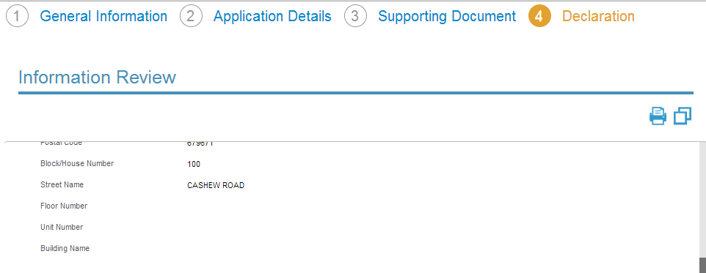
17 | Click on the 3 declaration statements then click “proceed with payment”. | 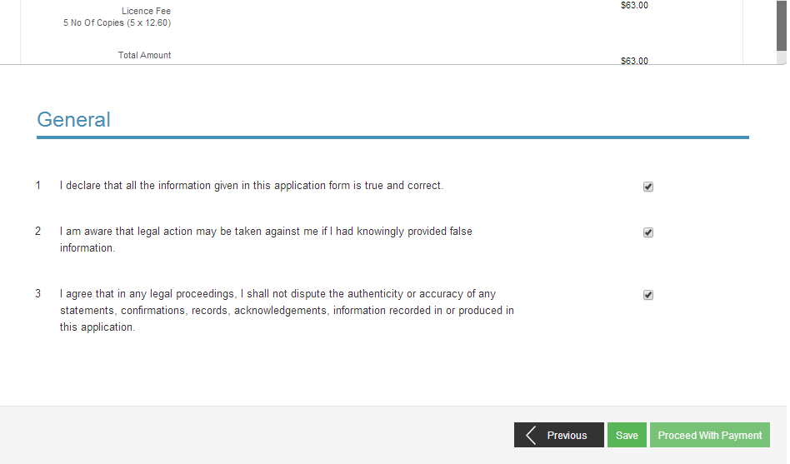
18 | Click “proceed with payment”. | 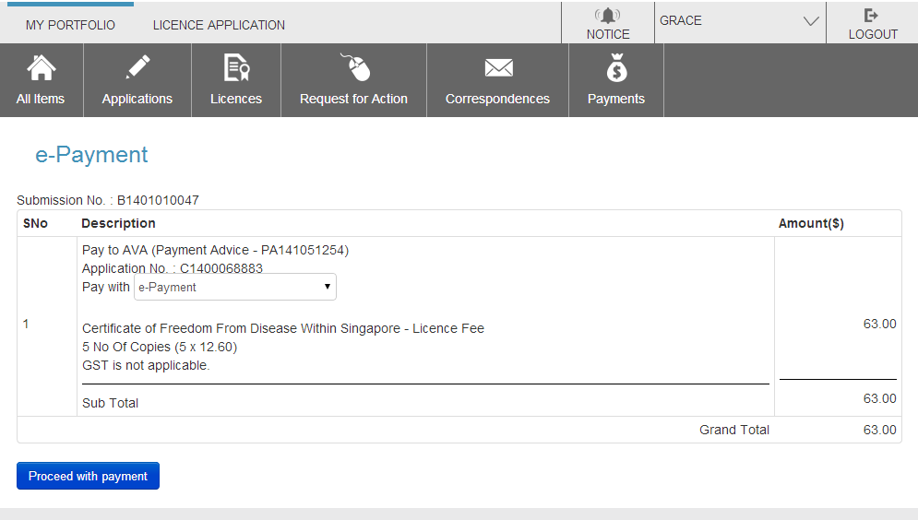
19 | Back at your homepage, you can view updates on your applications via “Applications”, “Licences”, “Request for action”, “Correspondences’, and “Payments”. | 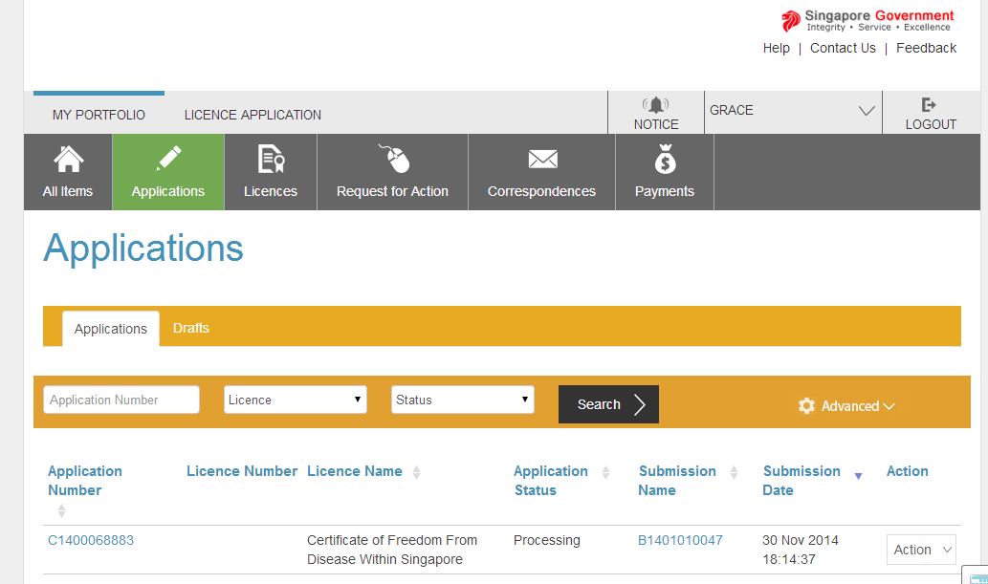

Additional Information
There are 2 types of Veterinary Certificates: Watermarked Certificates and Manually Endorsed Certificates.

For Watermarked Certificates:
- The certificate would be issued within 1 working day (Express Service) and 2 working days (Normal Service) after submission of complete supporting documents
- The cost of each certificate is S$46 (Express Service) and S$23 (Normal Service).
- You can collect the watermarked Health Certificate at AVA Headquarters, or print it with your personal printer which needs to have watermarked functions
- More information can be found at:
http://www.ava.gov.sg/AnimalsPetSector/ImportExportTransOfAnimalRelatedPrd/PetsPersonal/

For Manually Endorsed Certificates:
- The certificate would be issued within 1 working day from complete submission of supporting documents
- The cost of each certificate is S$23
- You need to bring the hardcopy template certificate to AVA service counter for manual endorsement
- More information can be found at:
http://www.ava.gov.sg/AnimalsPetSector/ImportExportTransOfAnimalRelatedPrd/PetsPersonal/

