Farm-to-Table (FTT) Recognition Programme
Logo Application Form

Note to Applicant

About the FTT Recognition Programme Logo
- The FTT Recognition Programme Logo is a logo award given to food businesses that procure at least 15% of local produce in any of the 6 food categories, i.e. Hen Shell Eggs, Leafy Vegetables, Beansprouts, Fish, Mushrooms, Quail Eggs.
- The logo is valid for 2 years from date of approval for logo usage. Food businesses will need to submit a new application for renewal thereafter.
- This is a tiered award system (3 tiers), where a higher tier will be awarded to food businesses that achieve at least 15% of local produce procurement in more food categories:
  - Base Tier – to achieve at least 1 food category
  - Mid Tier – to achieve at least 2 food categories
  - Highest Tier – to achieve at least 3 or more food categories
- The application will be assessed by dollar value, i.e.

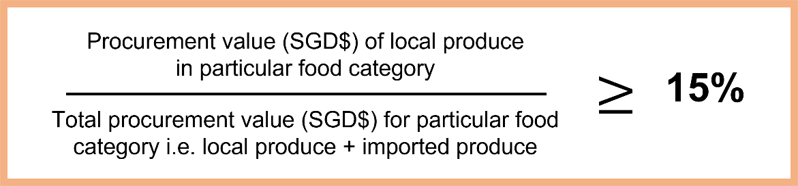

- Successful applicants will be subjected to random audits during the period of logo validity.

Submission through FormSG link
- Submission that is incomplete or ineligible will not be considered.
- Submission must be made through https://go.gov.sg/fttrplogo
- In your submission, you must submit all documents in a single zip folder through the FormSG link. Please name your folder as [Company Name_UEN Number]

Section 1: Applicant’s Details
Company Details
Company Name:

Company Address:

Type of Company:  Please only tick 1 | ☐Parent Company  ☐Subsidiary Company
Name of all Subsidiaries (if applicable):
For Group Level Application

UEN Number:

Business Description: | e.g. Chinese restaurant offering dim sum and seafood selection
SFA Licence Details
for each premise applying for

For more than 1 licence, you may provide the information in an excel file indicating Licensee Name, Licence Number, Licence Type, Licence Validity Period

Licensee Name:

Licence Number:
Licence Type:  You may tick more than 1 | ☐Food Shop Licence  ☐Food Stall Licence  ☐Food Manufacturing Licence
Licence Validity Period:  DD MM YYYY to DD MM YYYY | e.g. 3 Nov 2022 to 2 Nov 2023

Section 2: Submission Details and Supporting Documents
Number of Food Categories Meeting at Least 15% of Local Produce:  Please only tick 1 | ☐ 1 Category  ☐ 2 Categories  ☐ 3 or More Categories
Food Category (Type of Local Produce):  You may tick more than 1  Please ensure that it corresponds to the number of food categories | ☐ Hen Shell Eggs  ☐ Leafy Vegetables  ☐ Beansprouts  ☐ Fish  ☐ Mushrooms  ☐ Quail Eggs
Procurement Records  To submit 1 month’s worth of procurement records within the last 6 months at point of application, documents to include:  - Invoices of Local Produce and Imported Produce (in Zip folder)  - Summary of Procurement (in Excel sheet) – use the excel template downloadable on SFA’s website | Please provide the procurement records documents inside your zip folder  To note  Naming Format for Each Invoice:  Invoice Number_YYYYMMDD  Local produce invoice must contain the name and location (farm address) of the local farm  Imported produce invoice must contain the name of importer and country of origin of produce  Produce name must be clear, e.g. Xiao Bai Cai
Intended Usage of FTT Recognition Programme Logo  Provide examples of where the logo will be applied to | e.g. on the company website, shop front, food menu

Section 3: Declaration by Applicant

I hereby declare that the given information is true and complete at the point of submission of this application, and that any attempt to withhold or falsify the necessary information would render the business disqualified for the logo award.

Name of Applicant:
Designation of Applicant:
Email Address of Applicant:
Contact Number of Applicant:

Date of Submission
Signature of Applicant

